The most experienced instructor trainer in the Red sea
Mohamed Abd El-latif Ali

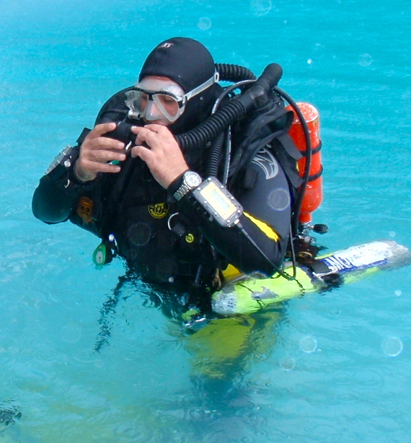
With over 23 years of teaching experience and more than 10500 dives in both recreational and technical diving.He's skills and knowledge, combined with some of the best dive sites in the world, creates a great experience for all divers, whether you are just starting out or looking to advance your skills and move into the exciting world of technical diving.
Educating recreational and technical divers by expertise and passion with best training agencies, IANTD/TDI/PADI/SDI and DAN

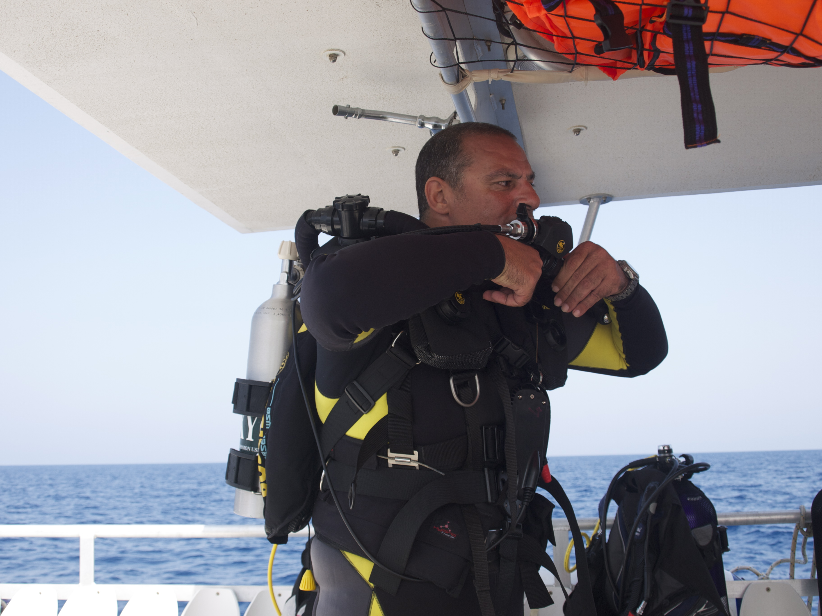
He is an
IANTD Trimix instructor Trainer Trainer
IANTD Trimix Blender Instructor Trainer Trainer
IANTD CCR MK 6 Instructor Trainer Trainer
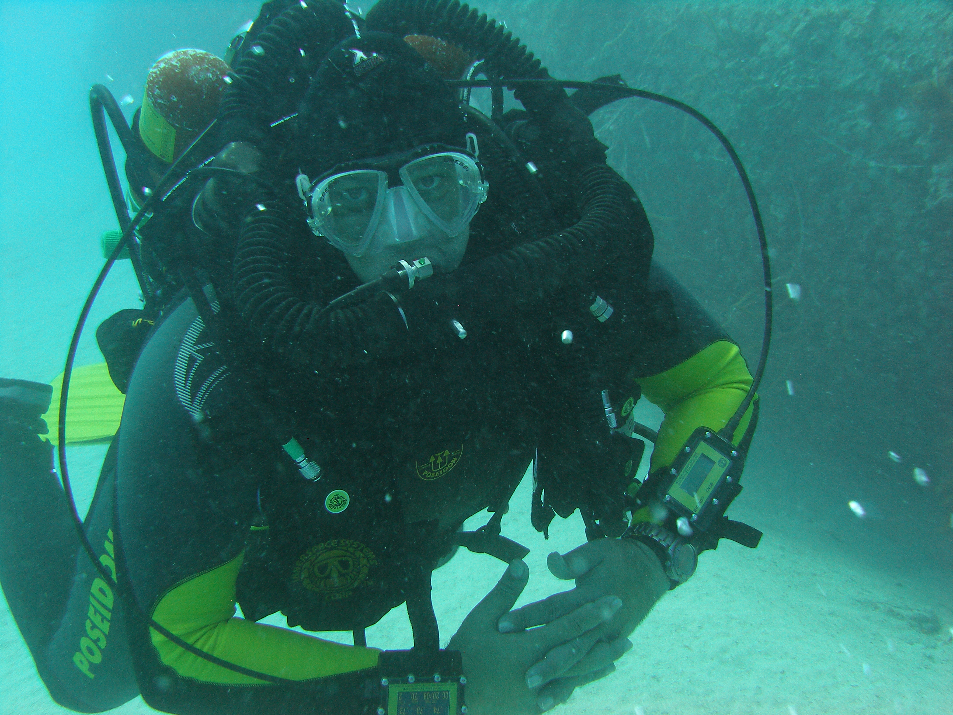
IANTD SideMount Instructor Trainer Trainer
PADI TEC Trimix Instructor Trainer
PADI TEC Trimix Blender Instructor Trainer
PADI TEC Side-mount Trainer
TDI Adv.Trimix Instructor Trainer
TDI Adv. Blender Instructor Trainer
SDI Course Director IT
EFR Instructor Trainer
DAN Instructor Trainer

